**TERRAFORM TASK 1**

Install Terraform on your PC

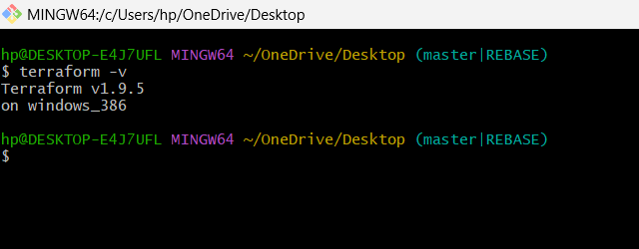

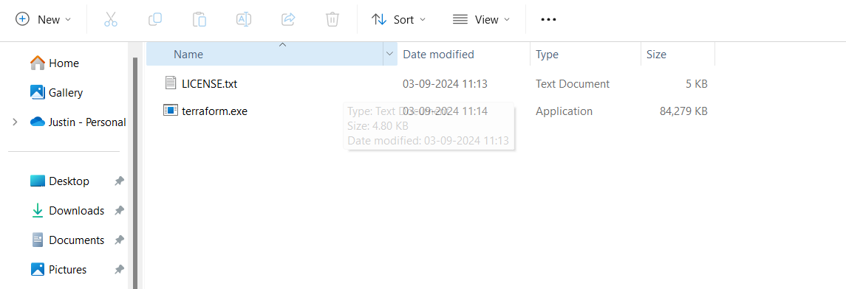

Execute all the templates shown in video.

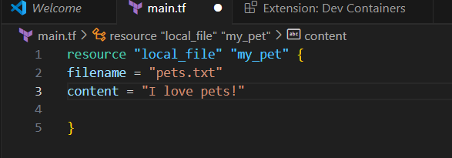

Here, In Terraform we can execute then & there itself in order to run or check the code

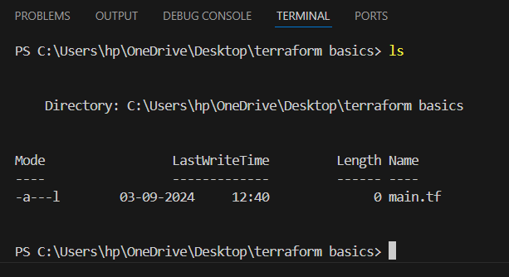

Terraform Init

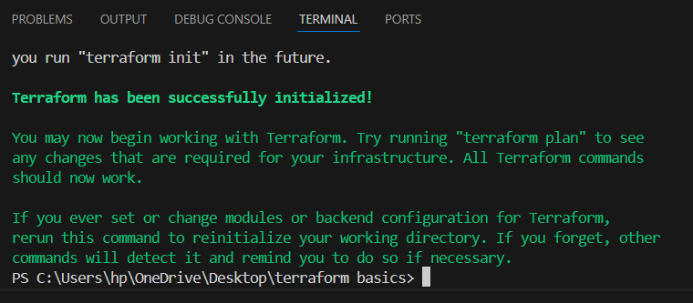

Terraform plan

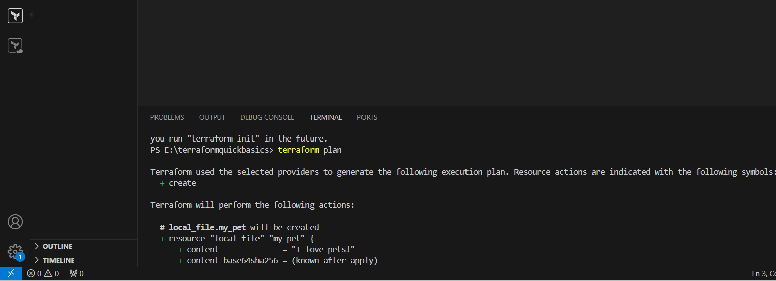

Terraform apply

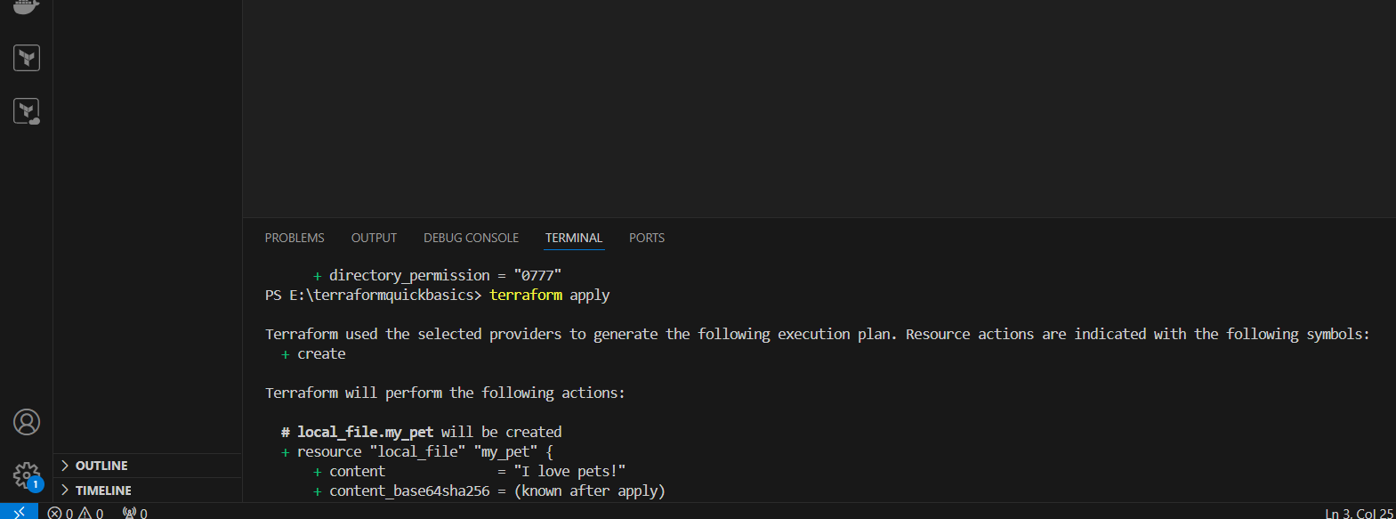

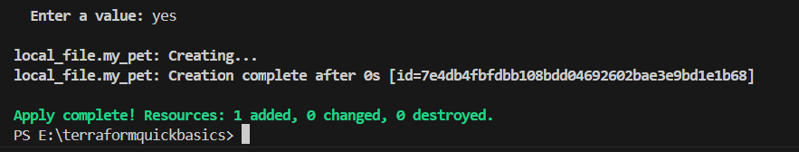

Terraform Providers

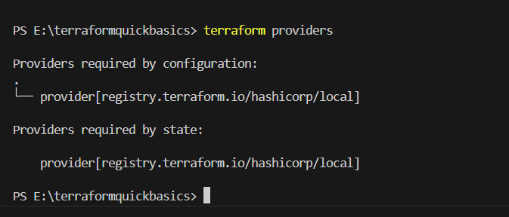

Terraform destroy (it is only to see what is happened in terminal)

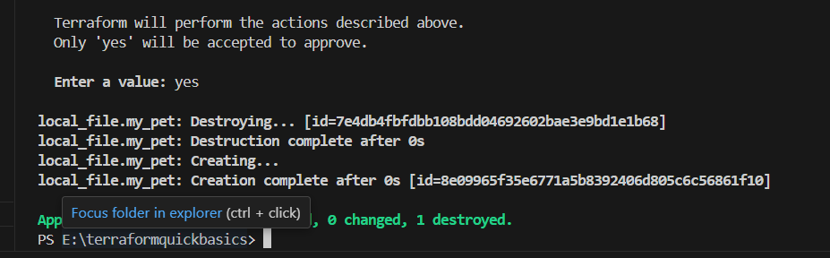

Integrate a sample Terraform template in jenkins.

**Explanation:-**

Go Jenkins server and install terraform and unzip.

After that go to Jenkins and go to tool configure and add terraform with path which is available in Jenkins server.

After that create a job.

Go to build steps add execute shell.

Type this command Terraform -v.

add run the job see the output

